

DECO3500 - Social and Mobile Computing

Team Charter

# 

# Team Members

Name: Kelsey Quinn

Student number: 41724336

Degree: Bachelor of Information Technology / Arts

E-mail: [kmquinn17@gmail.com](mailto:kmquinn17@gmail.com)

Roles: Design, User Research, Programming.

Name: Otis Carmichael

Student number: 45818626

Degree: Bachelor of Information Technology majoring in Software Development

E-mail: [ocarm0809@gmail.com](mailto:ocarm0809@gmail.com)

Roles: Team Leader, will be responsible for checking whether team members are on track and organising group meetings. Will work on the formation of the team’s design and will help to create the team’s prototype, while also conducting user research to shape our domain. In charge of communicating on behalf of the team.

Kendy Nguyen

Student number: 44334893

Degree: Bachelor of Information technology majoring in Software design

E-mail: [kendy@live.com.au](mailto:kendy@live.com.au)

Roles: Lead Programmer, UX design/designer

Name: Gloria Cheah Phaik Hui

Student number: 45194946

Degree: Bachelor of Information Technology (User Experience)

E-mail: [gloriacph1999@gmail.com](mailto:gloriacph1999@gmail.com)

Roles: Lead designer, UX design

GitHub Repository

<https://github.com/otili9890/hamilton-the-sheep>

# Team Communication Agreement

We will be using Facebook Messenger as the main communication platform with all members in the team for text messages. We will be using Discord to maintain communication through voice meetings. It is expected that team members will respond to messages within 24 hours if needed.

## Meeting Times and Rules

* Due to the coronavirus, meetings will be conducted online by voice calls on Discord, but physical meetings will be held as needed as long as team members are healthy, as well as in person studio sessions.
* Meetings times are not scheduled as it is not necessary yet.
* Meetings will be arranged such that at least 3 members are able to attend.
* Members will be notified of upcoming meetings at least 24 hours prior to the meeting.
* In the case of absence and lateness to the meetings, members are obliged to notify the others through Messenger or Discord.

## Methods of Decision-Making

* The group will discuss the pros and cons of each opinion and compromise on which is the most beneficial to the project.
* If team members disagree about the decision, the team will decide by majority vote.

## Workload Agreement

* Work will be distributed through discussion on Messenger. If there are tasks remaining after everyone has finished selecting tasks, they will be distributed more or less through discussion.
* When a member believes their work is complete, the other members of the team will review the work to determine if it’s of acceptable quality.
* Members must provide status updates on work done 3 days before the due date (e.g. work completed, work in progress, need assistance, etc).
* If a member is unable to complete a task and gives sufficient notice to that effect, the team will develop mitigation strategies as necessary.

# Conflict Resolution Agreement

## Conflict between Team Members

Escalation procedure:

1. Potential solutions will be discussed over online communication channels between the concerned members.
2. In the event that a resolution is not reached by the next meeting, the team will discuss potential solutions as a whole and vote on a consensus.
3. In the event that a resolution still isn’t reached, the situation will be escalated to a tutor.

## Underperforming Team Members

Escalation procedure:

1. The concerned member will be notified that they are behind schedule. Potential solutions will be discussed over online communication channels between the team.
2. In the event that the situation is not remedied by the next meeting, the team will discuss potential solutions as a whole and vote on a consensus.
3. In the event that the situation is still not remedied, the situation will be escalated to a tutor.

## Lack of Communication

When required, team members should maintain communication and reply to Messenger within 3 days. Tutors will be contacted as the following procedure:

Escalation procedure:

1. Written email will be sent to the team member(s) after 2 days of no communication to follow up the discussion.
2. Team member(s) will be contacted via email and slack after 3 days of no communication.
3. If the previous contact method fails and/or no action has been taken when required, course staff will be contacted via email to notify the current situation.

# Signatures

Kelsey Quinn Date: 4/09/2020

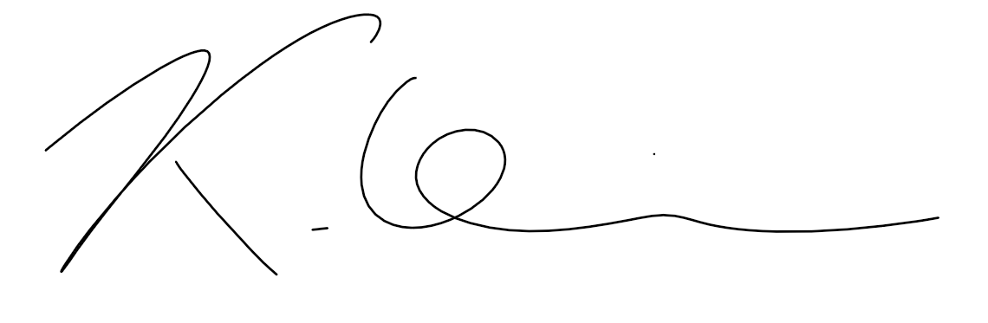

Otis Carmichael Date: 4/09/2020

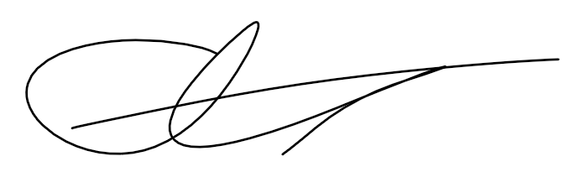

Kendy Nguyen Date : 4/09/2020



Gloria Cheah Date : 4/09/2020

